**Phase 2 Project**

**Github link for assignment and project**: [GitHub - JoswinDsouza99/SimplilearnPhase2: Assignment of Phase 2](https://github.com/JoswinDsouza99/SimplilearnPhase2)

**Flow of FlyAway:**

1. Login page for the user and a registration option at the bottom too

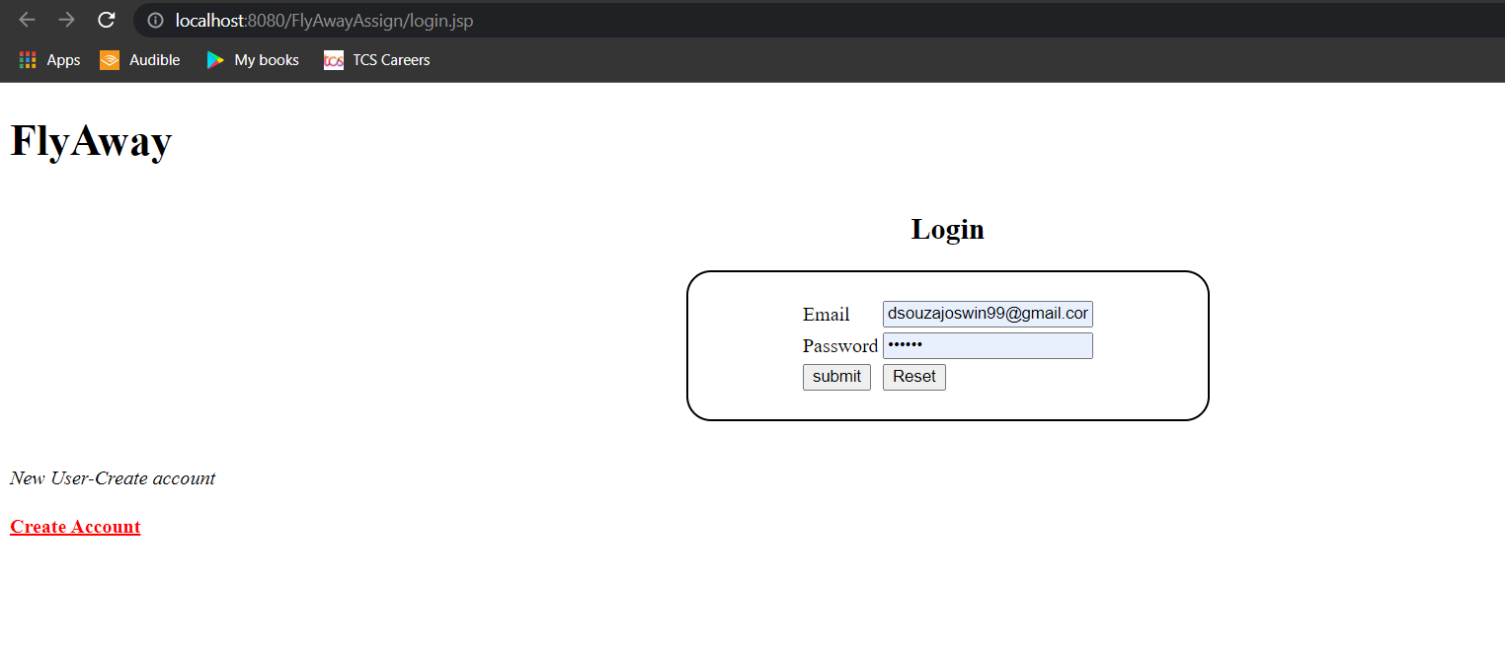

1. Creating a new user and registration page

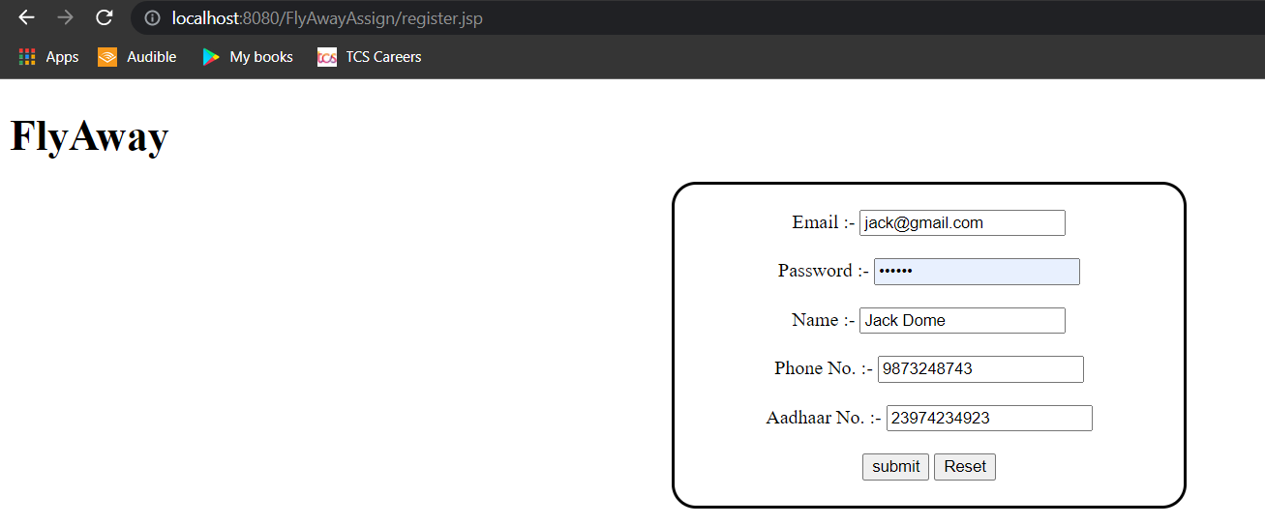

1. After logging in the user can enter details like source, destination and date.

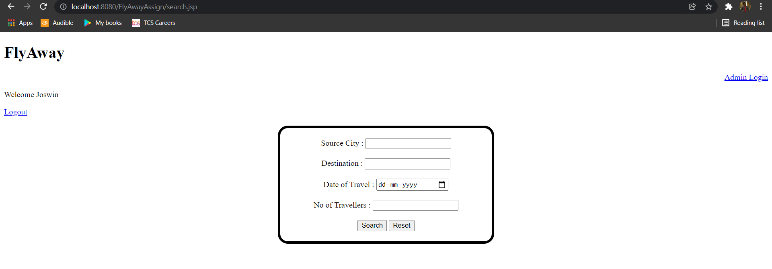

1. Entering the details in the flight page

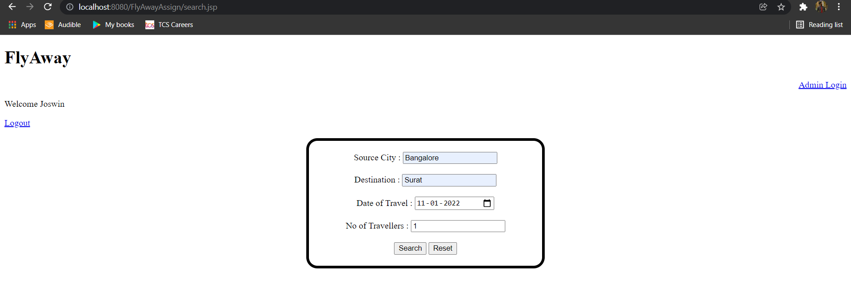

1. Based on the given inputs the flights are filtered and shown to the user

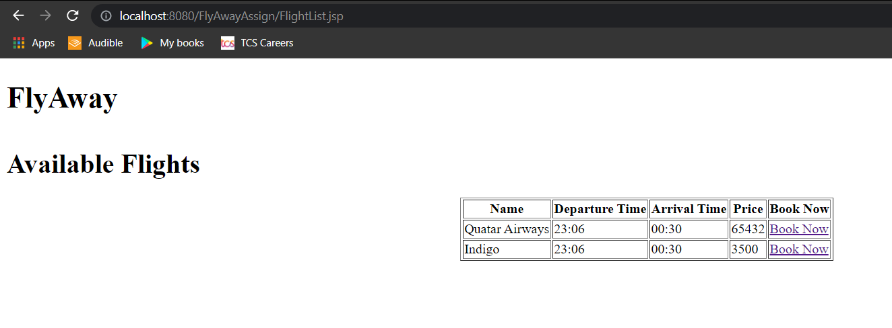

1. Once the user selects a flight the payment page generates the QR code

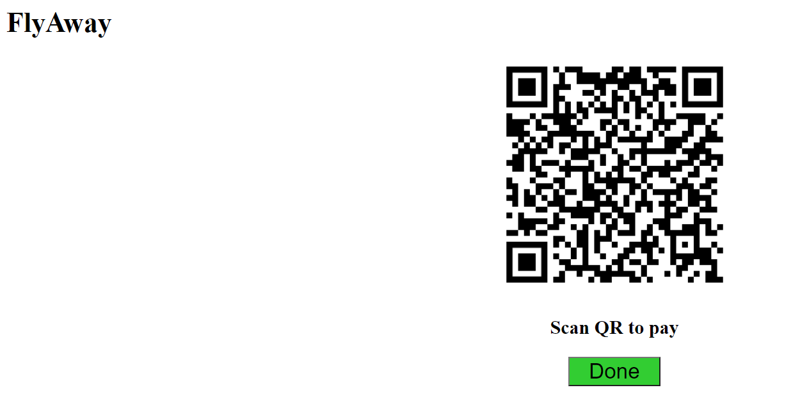

1. And once the payment is done it will redirect to the confirmation page

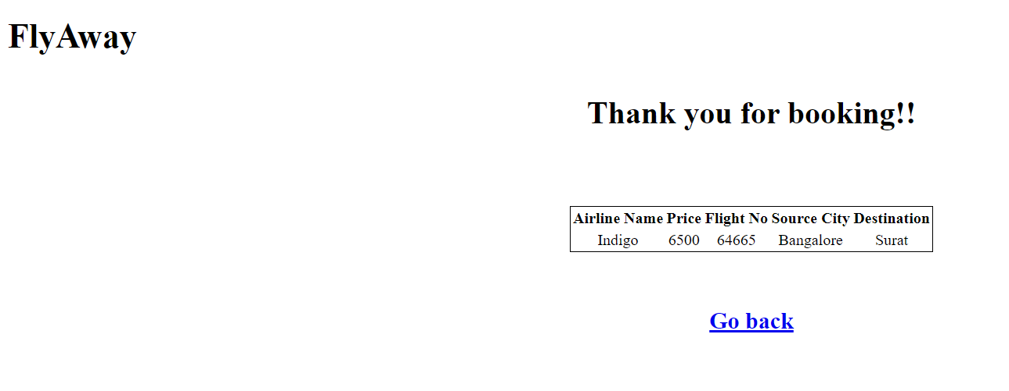

1. Admin can reset the passwords

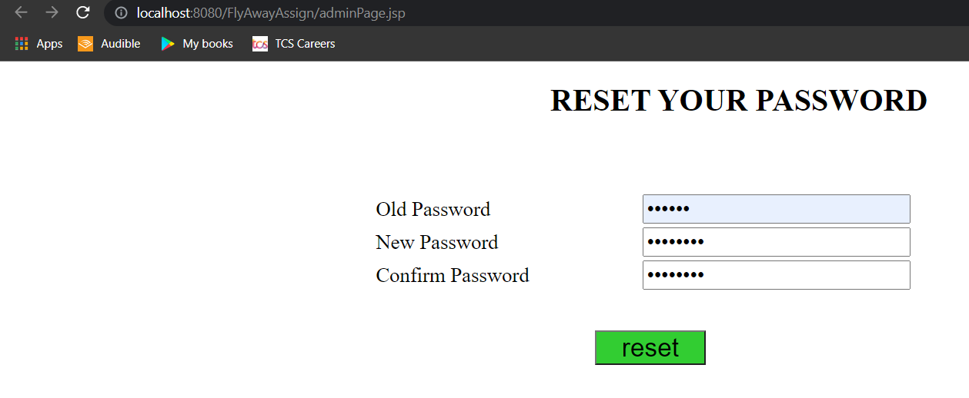

**The table descriptions:**

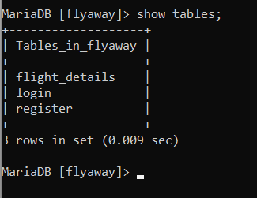

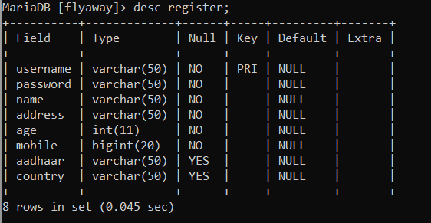

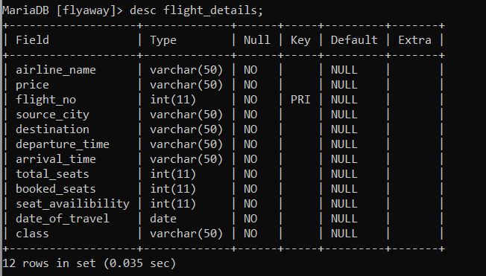

**Inferences:**

Mainly got to learn about the sql connection with my application and how can manipulate the data.

Using bean classes and servlets. Using techniques like exceptions, collections, and sorting techniques for source code optimization and increased performance